BIG DATA ANALYSIS ON H1B VISA PETITIONS

USING HADOOP

Presented by

BHEEMIDI VIKRAM REDDY

NIIT Secunderabad
 |  |  | INDEX
1. Introduction |  |  | 3
1.1 |  | What is Big data? | 3
 | 1.1.1 Characteristics of big data |  | 3
 | 1.1.2 Big data analytics |  | 4
1.2 |  | History of Hadoop | 4
1.3 |  | Hadoop | 5
 | 1.3.1 Hadoop Vs RDBMS |  | 5
 | 1.3.2 HDFS |  | 5
 | 1.3.3 MapReduce |  | 6
1.4 |  | Hadoop Ecosystem | 6
1.5 |  | Hive | 7
1.6 |  | Pig | 7
1.7 |  | Sqoop | 7
1.8 |  | Flume | 8
1.9 |  | Oozie | 8
2. | Project Outline |  | 8
3. | Project Objective |  | 10
4. | Project Implementation |  | 10
5. | Conclusion |  | 29
6. | Webography |  | 29

1. INTRODUCTION
1.1 What is Big data?

Big data is an all-encompassing term for any collection of data sets so large and complex that it becomes difficult to process them using traditional data processing applications.

A definition of Big Data could be "Big Data is not about size, but it's about granularity". The ability of software systems to identify individuals and personalized data is the ironic implication of "Big". It is the ability to focus on the minutiae of the individual, in real time.

Extremely large data sets that may be analyzed computationally to reveal patterns, trends, and associations, especially relating to human behavior and interactions.

1.1.1 Characteristics of Big Data

- Volume(scale of data) - the data which is generated in today’s modern era is in very large size i.e., ~ petabytes of data per day which should be handled, stored, processed and used with utmost concern.

- Velocity(analytics of streaming of data) – velocity means the rate of occurrence or the rapidity of motion. In this data world, velocity means the rate at which the data is getting generated or accumulated in the databases.

- Variety(different forms of data) – data does not have any single format or fixed structure or schema, it can be any one of them like images, audio files, videos, log files, xml, excel files, tables etc. The data is categorized into three forms structured, semi-structured, unstructured.

- Veracity(uncertainty of data) – As the data is collected from different sources, it must be trustworthy. Veracity means trustworthiness of the data.

- Value(what we get are researching) – The data or the value which we get after diving deep into the data and performing various operations like storing, analyzing, processing, and generating the output. The value which we get after researching should be useful in real-time systems or for the development of any business organization.
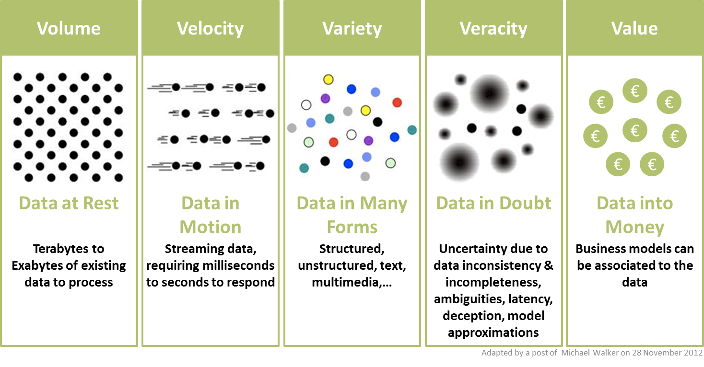

1.1.2 Big Data Analytics

It is the process of examining large data sets containing a variety of data types- i.e., big data – to uncover hidden patterns, unknown correlations, market trends, customer preferences and other useful business information.

1.2 History of Hadoop

We all know about the Google search engine which processes the request of millions of users daily. For executing and displaying the result of queries of those many users daily would be a heavy task. In 1990, problem got raised for storing data as it have to store a huge amount of data to satisfy the needs of millions of users from all over the world. It took 13years to find a solution to that problem as it can’t be solved by using traditional databases. In 2003, GFS(Google File System) and in 2004, MapReduce was introduced by Google for storing and processing huge quantities of data. This solution was a discovery not an implementation method. It is a theoretical paper which describes how to solve that problem and what should be the measures to be taken. The inventor and founder of hadoop is Doug Cutting. During the project, everyone was thinking about the logo for the new discovery. One fine day Doug observed his son playing with an elephant toy to which he gave the name as hadoop. At that moment he decided to name their inventory as hadoop.

1.3 Apache Hadoop
Hadoop is an open-source framework given by Apache Software Foundation for storing huge datasets and processing huge datasets with cluster of commodity hardware. It has two main components namely hadoop distributed filesystem and mapreduce.

1.3.1 HADOOP VS RDBMS

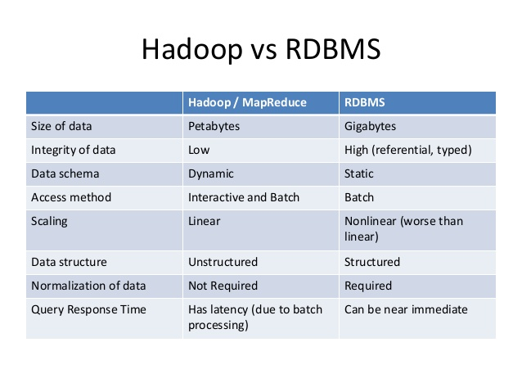

1.3.2 Hadoop Distributed File System(HDFS)

Hadoop distributed file system is a specially designed file-system for storing large datasets with cluster of commodity hardware and with streaming access pattern. Here cluster is a group of data nodes or network of machines or processors where each of them having their own primary storage(ex-RAM) and secondary storage(ex-harddisk). The hardware used in hadoop file system will be at low cost i.e., we don’t require costly machines for storing and processing our data.

Hadoop need not to be worked on highly reliable hardware. It can be worked on simple cheap hardware.

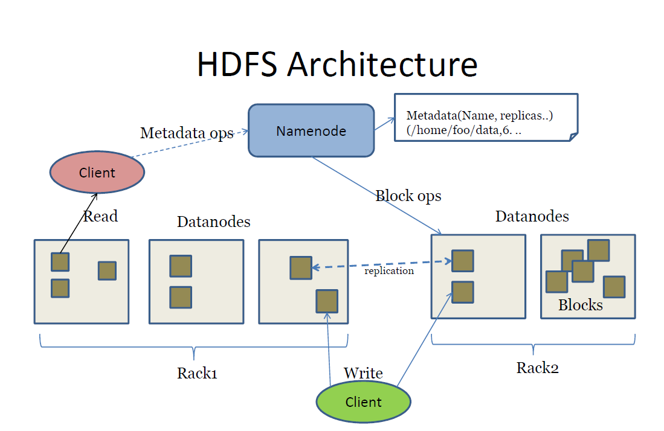

1.3.3 MapReduce
Apache MapReduce is a software framework for easily writing applications which process vast amounts of data (multi-terabyte data-sets) in-parallel on large clusters (thousands of nodes) of commodity hardware in a reliable, fault-tolerant manner. MapReduce idea is inspired from similar paradigm used by functional programming languages like LISP. Their programs are easy to run in distributed environment.

In 2003, Google has introduced the MapReduce concept but later in December 2004, it published a paper explaining architecture of MapReduce.

A MapReduce job usually splits the input data-set into independent chunks which are processed by the map tasks in a completely parallel manner. The framework sorts the outputs of the maps, which are then input to the reduce tasks. Typically both the input and the output of the job are stored in a file-system. The framework takes care of scheduling tasks, monitoring them and re-executes the failed tasks.

Typically the compute nodes and the storage nodes are the same, that is, the MapReduce framework and the Hadoop Distributed File System are running on the same set of nodes. This configuration allows the framework to effectively schedule tasks on the nodes where data is already present, resulting in very high aggregate bandwidth across the cluster.

MapReduce has two core functions: Mapper in which filteration and extraction of data is done in key, value pair and passed to the lowest logical level and Reducer where the mapper output is taken as input in the key, value pair and the aggregate operation is performed. The actual operation and business logic is written in reducer class.

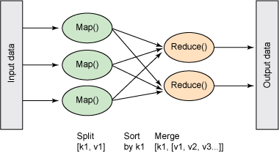


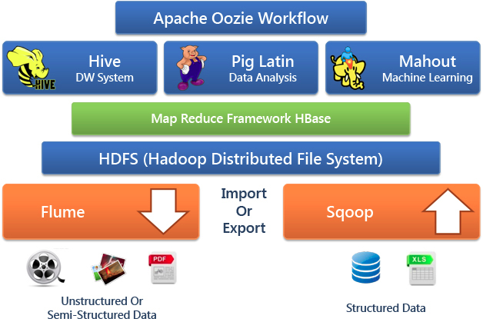
1.4 Hadoop Ecosystem
HDFS- framework for storing our files
Mapreduce- framework used for processing the files stored in our HDFS

Flume, Sqoop- tools helpful to import/export the data(data loading tools)

Zookeeper- tool used for synchronizing the various services present in the hadoop framework

Oozie- tool used to keep the track of the workflow

Hive, Pig- frameworks used for processing the stored data

Mahout- framework provides an environment for creating machine learning applications

R Connectors- tool used for predictive analysis

HBase- nosql database

1.5 HIVE

Hive is a data warehouse system layer built on Hadoop which allows you to define a structure for your big data and simplifies analysis and queries with an SQL-like scripting language called HiveQL.

Hive uses a database to store metadata, but the data that hive process is stored in hdfs. Simply hive is nothing but which allows to run structured query on unstructured data.

1.6 PIG

Pig is an in memory processing tool and also said to be data flow language which supports all data formats. In pig we have grunt shell and by default data type will be byte array. Pig provides a high-level language known as Pig Latin.

In Apache Pig, schema is optional. We can store data without designing a schema (values are stored as $1, $2 etc.)

1.7 SQOOP

Sqoop is a tool designed to transfer data between Hadoop and relational databases or mainframes. You can use Sqoop to import data from a relational database management system (RDBMS) such as MySQL or Oracle or a mainframe into the Hadoop Distributed File System (HDFS), transform the data in Hadoop MapReduce, and then export the data back into an

RDBMS.1.8 FLUME

Apache Flume is a distributed, reliable, and available system for efficiently collecting, aggregating and moving large amounts of log data from many different sources to a centralized data store. The use of Apache Flume is not only restricted to log data aggregation. Since data sources are customizable, Flume can be used to transport massive quantities of event data including but not limited to network traffic data, social-media-generated data, email messages and pretty much any data source possible. Apache Flume is a top level project at the Apache Software Foundation.

1.9 OOZIE
Oozie is a server based Workflow Engine specialized in running workflow jobs with actions that run Hadoop Map/Reduce and Pig jobs. For the purposes of Oozie, a workflow is a collection of actions (i.e. Hadoop Map/Reduce jobs, Pig jobs) arranged in a control dependency DAG (Direct Acyclic Graph) "control dependency" from one action to another means that the second action can't run until the first action has completed. Oozie workflows contain control flow nodes and action nodes.

1.10 ZOOKEEPER

ZooKeeper is a distributed co-ordination service to manage large set of hosts. Co-ordinating and managing a service in a distributed environment is a complicated process. ZooKeeper solves this issue with its simple architecture and API. ZooKeeper allows developers to focus on core application logic without worrying about the distributed nature of the application.

2. PROJECT OUTLINE

Title | BigData Analysis in Hadoop on H1b Visa Petitions (2011-2016).
Inputs | H1b Visa Petitions
Data Elements | case_status,employer_name,soc_name,full_time_position,job_title,  prevailing_wage,year,worksite,longitude,latitude .
Analysis Relevance | 12 insights for better understanding of immigrants over US
Purpose | To provide Analyzed Results to US immigration department for better understanding about the immigrants who are applying for US h1b visa
Methodology | Agile

The dataset of my project is a US H1b Visa Petitions from year 2011-2016 which depicts the complete details of an individual immigrant who are applying for h1b in a US country. The dataset consists of nearly 30 lakh records in which the data is divided into ten columns including case_status,employer_name,soc_name,full_time_position,job_title,prevailing_wage,year,worksite,longitude,latitude .

Hadoop framework is used in my project as the main component for implementing the project as it is an open-source Apache Software Foundation product, more efficient compared to RDBMS in terms of performance, storage and faster query processing. In my project I have used HDFS(Hadoop Distributed FileSystem) for the storage of input and output results of my project. MapReduce, Hive, Pig are the processing tools used for processing the data stored in my HDFS. Sqoop and Flume are used for importing/exporting the data into/from the HDFS to the required location. Zookeeper is used as the co-ordination tool for synchronizing the services of the various modules present in the hadoop framework. Oozie helped for maintaining the workflow in my project among the modules. After diving deep into this data and with the help of these modules, I got the results which can be used in real-time for the development of the life of the mankind.

The methodology used in my project is agile software model. Agile is a software development methodology to build a software incrementally using short iterations of 1 to 4 weeks so that the development is aligned with the changing business needs.

3. PROJECT OBJECTIVE
The main objective of my project is to do analytical processing which leads to insights for the US

immigration department to know better about the immigrants who are applying for H1b visa and

to know median prevailing wage of each employer according to jobtitle.

4. PROJECT IMPLEMENTATION

Before Analyzing the Dataset directly i have preprocessed all the quotations included in it which is unwanted and i removed leading spaces and tab spaces in between columns using Hive.
The preprocessing donw in the following way:

CREATE TABLE h1b_applications(s_no int,case_status string, employer_name string, soc_name string, job_title string, full_time_position string,prevailing_wage int,year string, worksite string, longitute double, latitute double )

ROW FORMAT SERDE 'org.apache.hadoop.hive.serde2.OpenCSVSerde'

WITH SERDEPROPERTIES (

"separatorChar" = ",",

"quoteChar" = "\""

) STORED AS TEXTFILE;

Before loading our dataset into hive table i need to take care of block size in HDFS_SITE Configuration file to 64 mb.

<property>
<name>dfs.blocksize</name>
<value>67108864</value>
<description>block size</description>
</property>

So,after loading data we have to preprocess again that i have null value records in those and some columns have NA also.

On analyzing the columns given in the dataset, we can categorize the data into few most important insights.

- a)Is the number of petitions with Data Engineer job title increasing over time?
b) Find top 5 job titles who are having highest avg growth in applications.
- a)Which part of the US has the most Data Engineer jobs for each year?
b) find top 5 locations in the US who have got certified visa for each year.
- Which industry(SOC_NAME) has the most number of Data Scientist positions?
- Which top 5 employers file the most petitions each year? - Case Status – ALL
- Find the most popular top 10 job positions for H1B visa applications for each year?
a) for all applications.
b) for only certified applications.
- Find the percentage and the count of each case status on total applications for each year. Create a line graph depicting the pattern of All the cases over the period of time.
- Create a bar graph to depict the number of applications for each year
- Find the average Prevailing Wage for each Job for each Year (take part time and full time separate). Arrange the output in descending order.
- Which are the employers along with the number of petitions who have the success rate more than 70% in petitions. (total petitions filed more than 1000) ?
- Which are the job positions along with the number of petitions which have the success rate more than 70% in petitions (total petitions filed more than 1000)?
- Export result for question no 10 to MySql database.

Firstly,before processing in Hadoop we have some prerequisites to follow
i.e the block size must be of 64 mb size.

And 12 questions can be done in 3 modules MapReduce,Pig,Hive but atleast 4 from each module is mandatory.
1.a) Is the number of petitions with Data Engineer job title increasing over time?

MAP REDUCE:

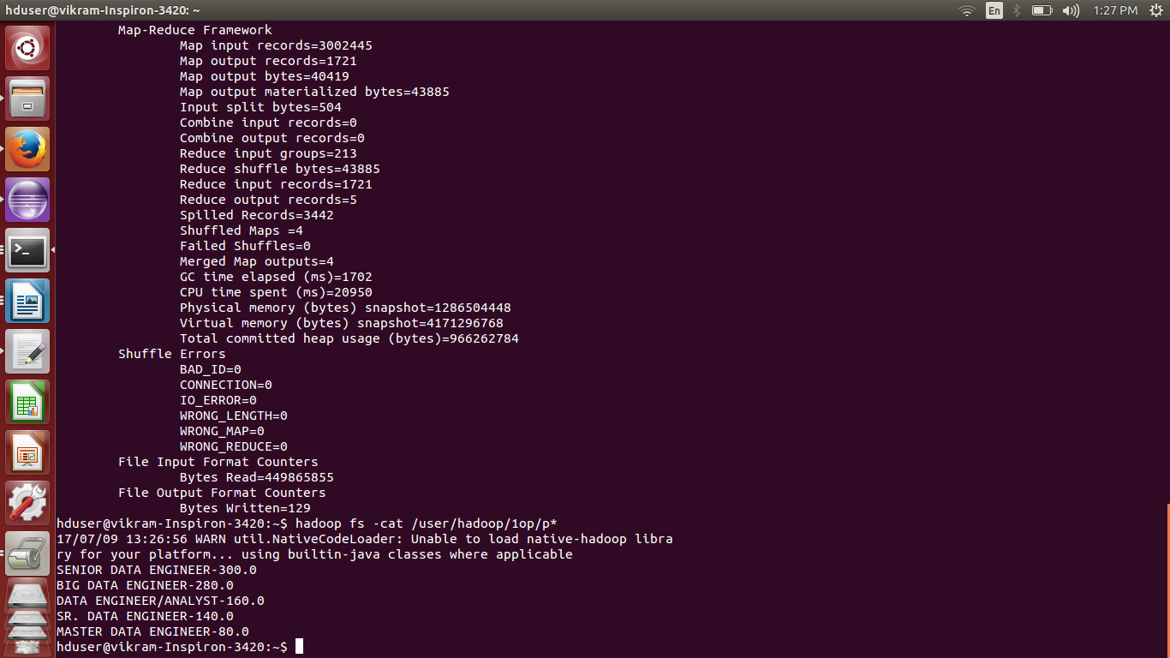

The result of this query leads

1.b) b) Find top 5 job titles who are having highest avg growth in applications.

MAP REDUCE:

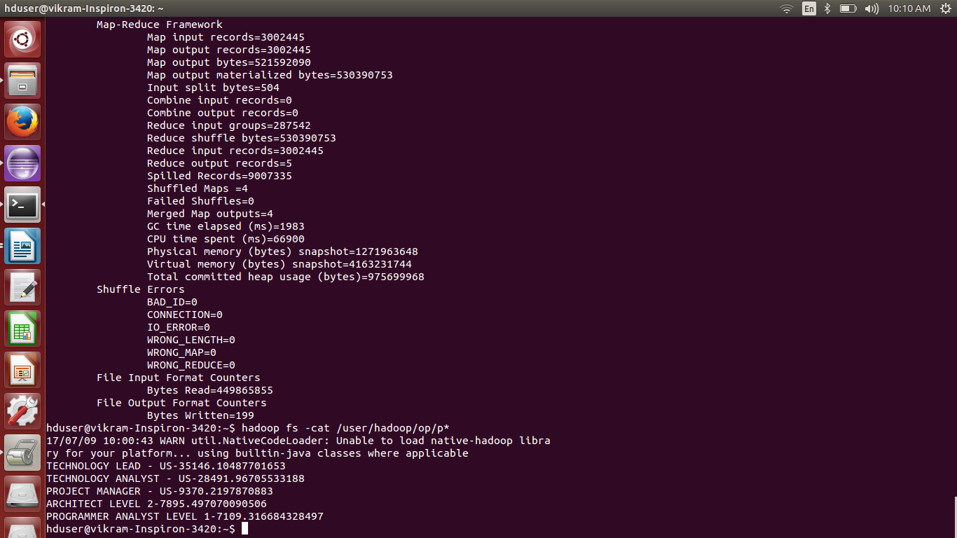

2 a) Which part of the US has the most Data Engineer jobs for each year?

MAP REDUCE:

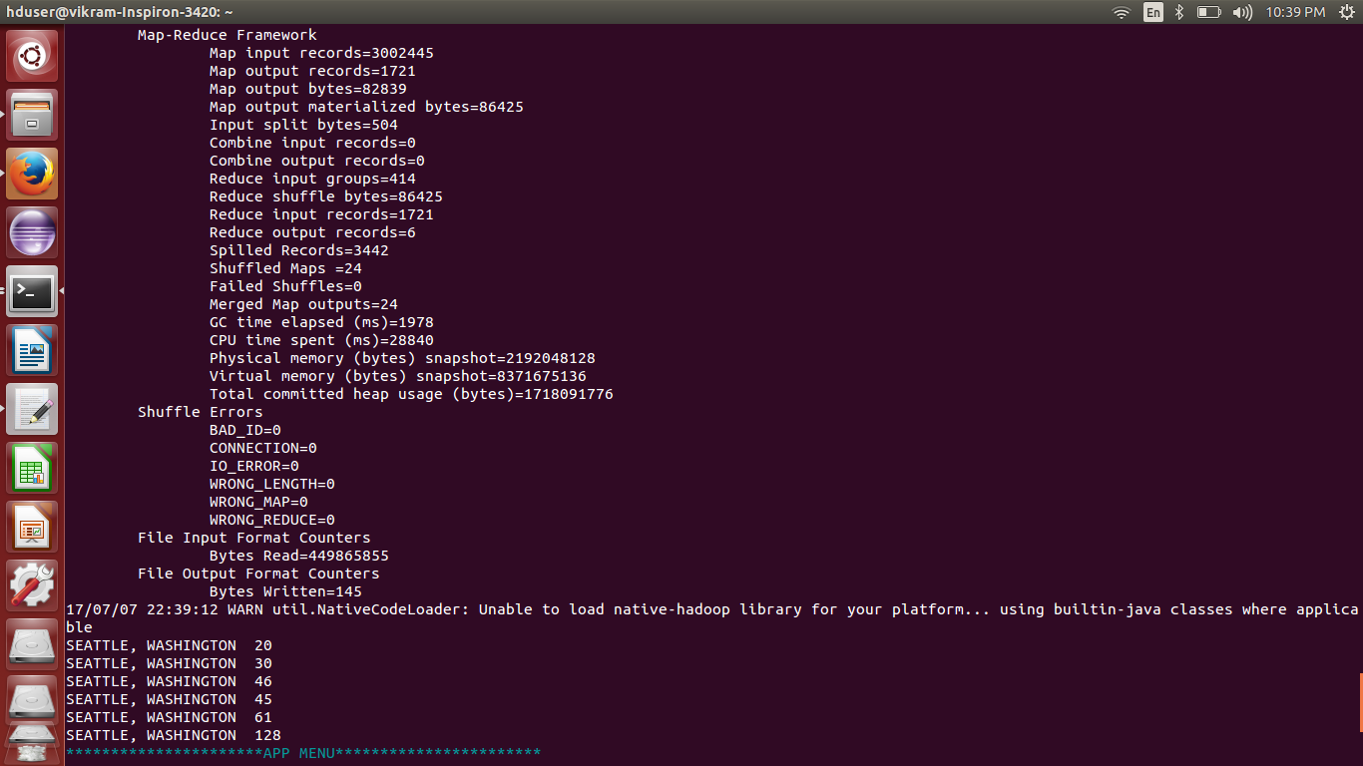

2 b) find top 5 locations in the US who have got certified visa for each year?

MAP REDUCE:

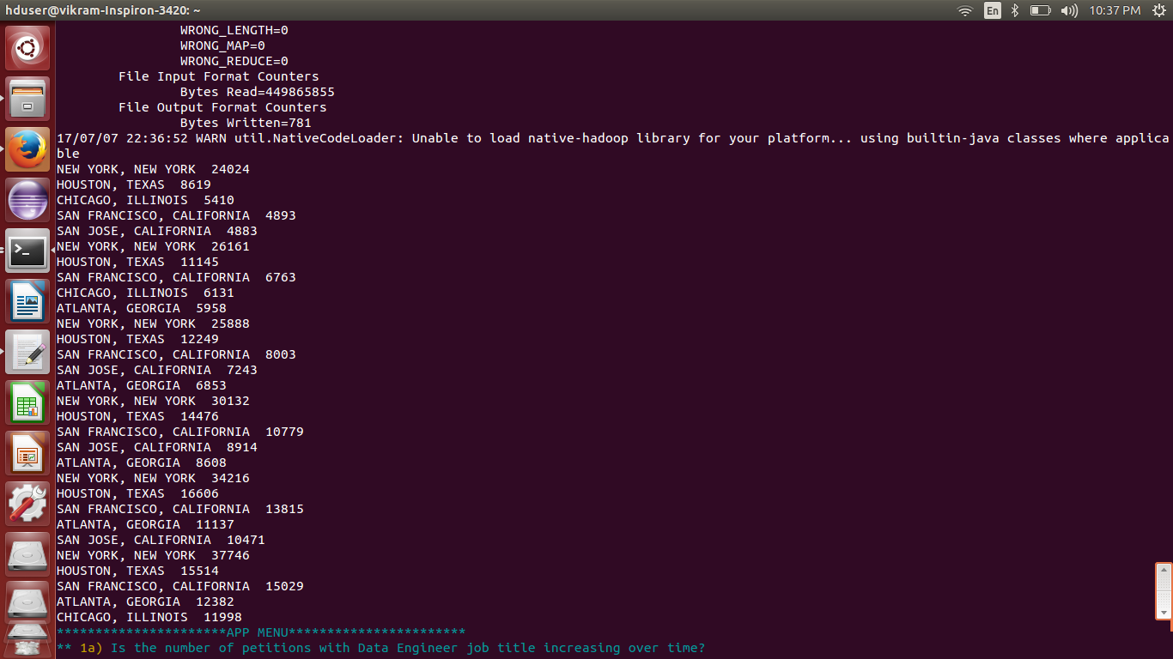

3)Which industry(SOC_NAME) has the most number of Data Scientist positions?

HIVE:
select soc_name,count(soc_name) as cnt from h1b_final where job_title LIKE '%DATA SCIENTIST%' group by soc_name order by cnt desc limit 1;

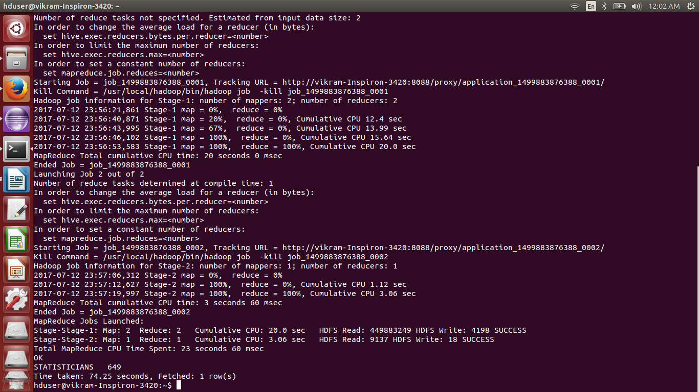

4)Which top 5 employers file the most petitions each year? - Case Status – ALL

MAP REDUCE:

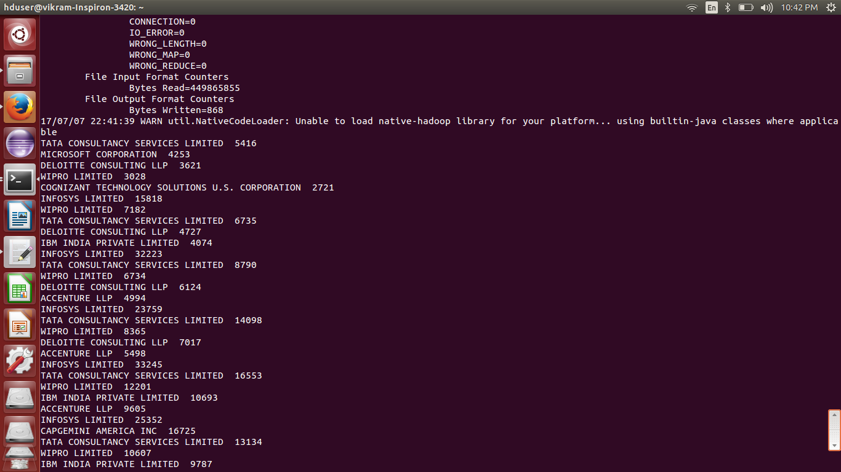

5) Find the most popular top 10 job positions for H1B visa applications for each year?
a) for all the applications

HIVE:
drop view table2;

create view table2 as select job_title,year,count(*) as total from h1b_final where year in ('2011','2012','2013','2014','2015','2016') group by year,job_title sort by year,total desc;

select year,job_title,total,rank from(select year,job_title,rank() over (partition by year order by total desc) as rank,total from table2) ranktable where ranketable.rank <=10;

drop view table2;

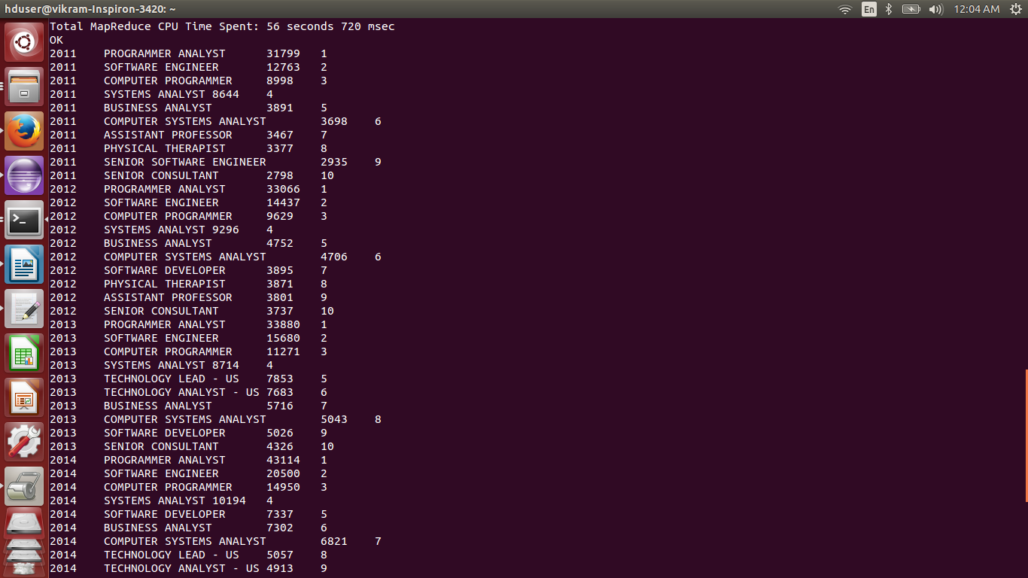

5) Find the most popular top 10 job positions for H1B visa applications for each year?
B) only for certified applications.

HIVE:
drop view table5;

create view table5 as select job_title,year,count(*) as total from h1b_final where year in ('2011','2012','2013','2014','2015','2016') and case_status='CERTIFIED' group by year,job_title sort by year,total desc;

select year,job_title,total,rank from(select year,job_title,rank() over (partition by year order by total desc) as rank,total from table5) ranktable where ranktable.rank <=10;

drop view table5;

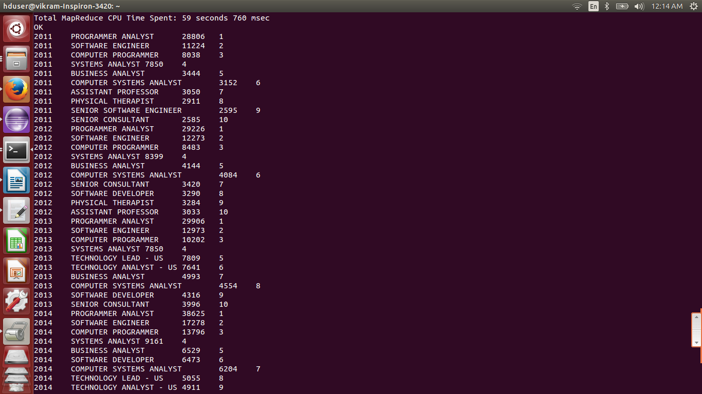

6) Find the percentage and the count of each case status on total applications for each year. Create a line graph depicting the pattern of All the cases over the period of time.

HIVE:
drop view cntyear;

drop view cntcasestatus;

create view cntyear as select year,count(case_status) as count1 from h1b_final group by year;

create view cntcasestatus as select year,case_status,count(case_status) as count2 from h1b_final group by case_status,year;

select a.year,b.case_status,b.count2,round(((b.count2/a.count1)*100),2) as percentage from cntyear a,cntcasestatus b where a.year=b.year order by year,percentage desc;

drop view cntyear;

drop view cntcasestatus;

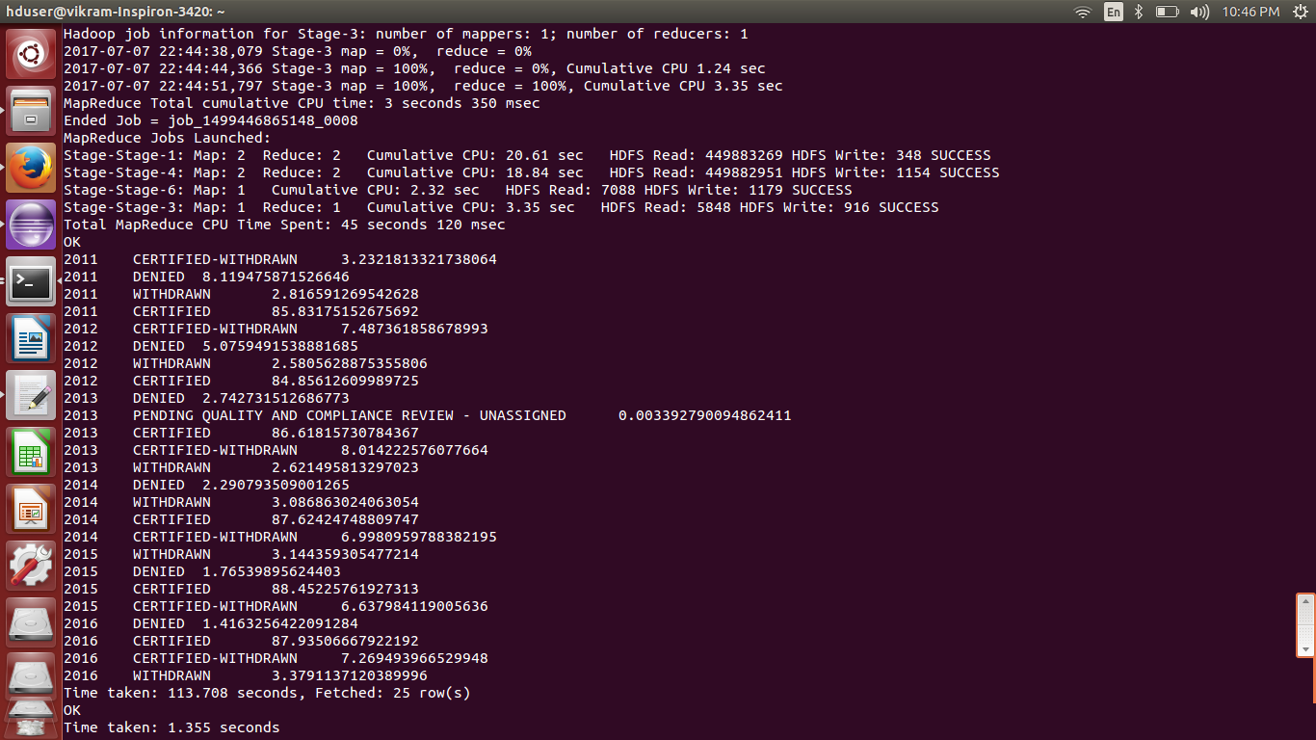

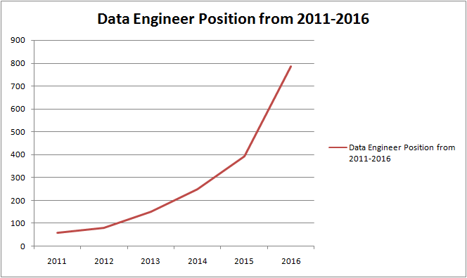

7) Create a bar graph to depict the number of applications for each year
PIG:
bag1 = load '/user/hive/warehouse/h1b_final' using PigStorage('\t') as (sno:int,casestatus:chararray,employername:chararray,socname:chararray,jobtitle:chararray,fulltime:chararray,prevailingwage:double,year:int,worksite:chararray,longitude:float,latitude:float);

bag2= group bag1 by year;

bag3= foreach bag2 generate group,COUNT(bag1.casestatus);

dump bag3;

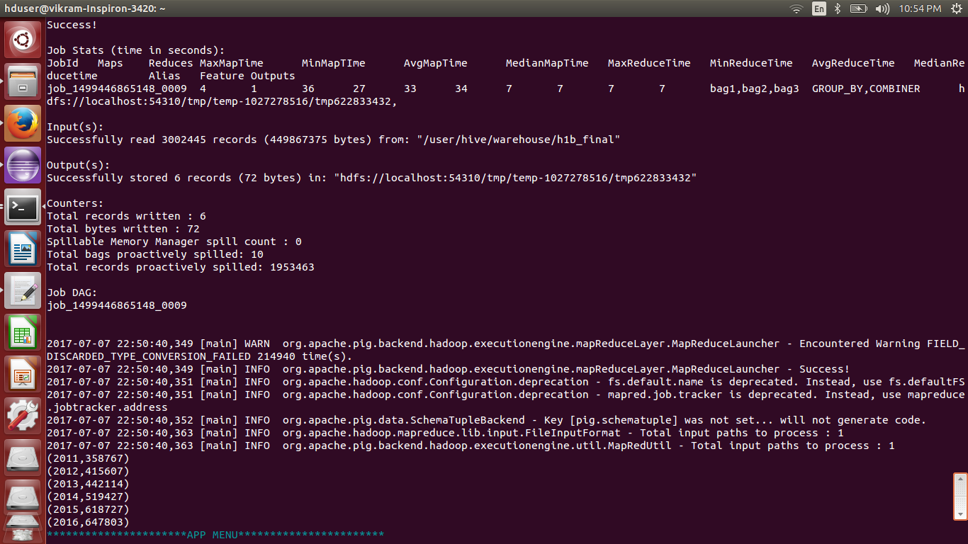

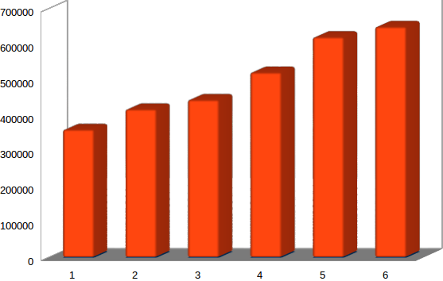

8) A.Find the average Prevailing Wage for each Job for each Year (take part time ). Arrange the output in descending order.
PIG:
bag1 = load '/user/hive/warehouse/h1b_final' using PigStorage('\t') as (sno:int,casestatus:chararray,employername:chararray,socname:chararray,jobtitle:chararray,fulltime:chararray,prevailingwage:double,year:int,worksite:chararray,longitude:float,latitude:float);

bag2= filter bag1 by fulltime=='Y';

bag3= group bag2 by (year,jobtitle);

bag4= foreach bag3 generate group,AVG(bag2.prevailingwage) as avg;

bag5= order bag4 by avg desc;

dump bag5;

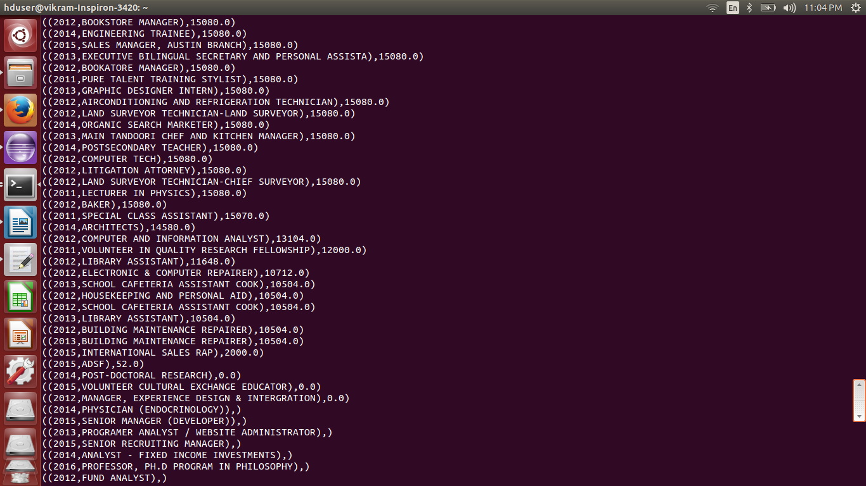

8) B.Find the average Prevailing Wage for each Job for each Year (full time separate). Arrange the output in descending order.
PIG:
bag1 = load '/user/hive/warehouse/h1b_final' using PigStorage('\t') as (sno:int,casestatus:chararray,employername:chararray,socname:chararray,jobtitle:chararray,fulltime:chararray,prevailingwage:double,year:int,worksite:chararray,longitude:float,latitude:float);

bag2= filter bag1 by fulltime=='N';

bag3= group bag2 by (year,jobtitle);

bag4= foreach bag3 generate group,AVG(bag2.prevailingwage) as avg;

bag5= order bag4 by avg desc;

dump bag5;

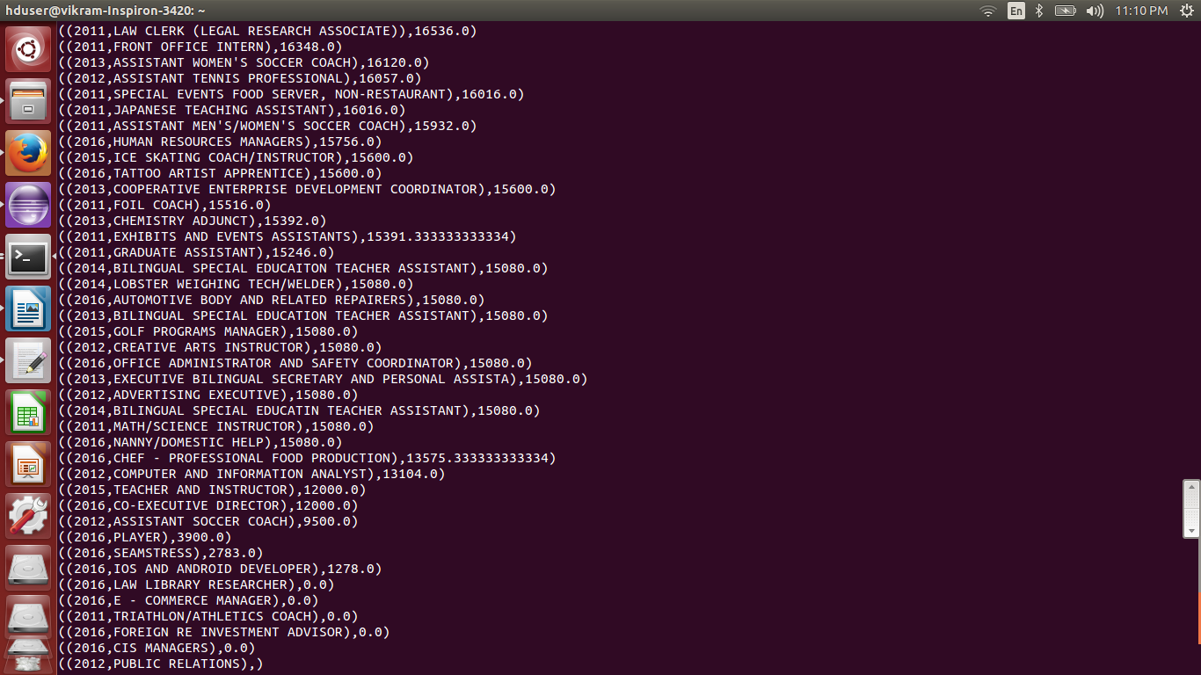

9) Which are the employers along with the number of petitions who have the success rate more than 70% in petitions. (total petitions filed more than 1000) ?
PIG:
bag1 = load '/user/hive/warehouse/h1b_final' using PigStorage('\t') as (sno:int,casestatus:chararray,employername:chararray,socname:chararray,jobtitle:chararray,fulltime:chararray,prevailingwage:double,year:int,worksite:chararray,longitude:double,latitude:double);

bag2= group bag1 by employername;

bag3= foreach bag2 generate group,COUNT(bag1);

bag4= filter bag3 by $1>1000;

bag5= filter bag1 by casestatus=='CERTIFIED';

bag6= group bag5 by employername;

bag7= foreach bag6 generate group,COUNT(bag5);

bag8= filter bag1 by casestatus=='CERTIFIED-WITHDRAWN';

bag9= group bag8 by employername;

bag10= foreach bag9 generate group,COUNT(bag8);

bag11= join bag4 by group,bag7 by group,bag10 by group;

bag12= foreach bag11 generate $0,((($3+$5)*100)/$1) as per;

bag13= filter bag12 by $1>70;

bag14= order bag13 by $1 desc;

dump bag14;


10) Which are the job positions along with the number of petitions which have the success rate more than 70% in petitions (total petitions filed more than 1000)?
PIG:
bag1 = load '/user/hive/warehouse/h1b_final' using PigStorage('\t') as (sno:int,casestatus:chararray,employername:chararray,socname:chararray,jobtitle:chararray,fulltime:chararray,prevailingwage:double,year:int,worksite:chararray,longitude:double,latitude:double);

bag2= group bag1 by jobtitle;

bag3= foreach bag2 generate group,COUNT(bag1);

bag4= filter bag3 by $1>1000;

bag5= filter bag1 by casestatus=='CERTIFIED';

bag6= group bag5 by jobtitle;

bag7= foreach bag6 generate group,COUNT(bag5);

bag8= filter bag1 by casestatus=='CERTIFIED-WITHDRAWN';

bag9= group bag8 by jobtitle;

bag10= foreach bag9 generate group,COUNT(bag8);

bag11= join bag4 by group,bag7 by group,bag10 by group;

bag12= foreach bag11 generate $0,((($3+$5)*100)/$1) as per;

bag13= filter bag12 by $1>70;

bag14= order bag13 by $1 desc;

dump bag14;

store bag14 into '/home/hduser/result' using PigStorage('\t');

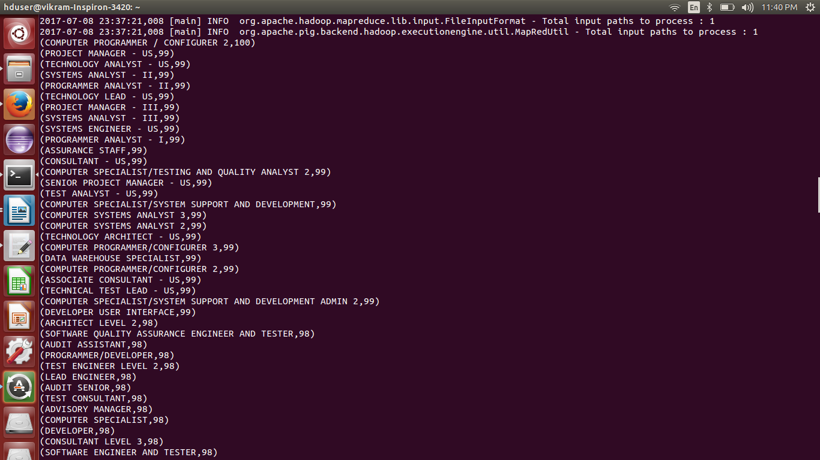

11) Export result for question no 10 to MySql database.

sqoop export --connect jdbc:mysql://localhost/h1b --username root --password '12345' --table h1bjobpositions --export-dir /home/hduser/result/part-r-00000 --input-fields-terminated-by '\t'

